# **SECTION 1: OVERVIEW OF EWB HONG KONG**

**1.1 Organization Background**

Engineers Without Borders (Hong Kong) Limited (hereinafter referred to as “EWB-HK”) is an engineering-based charitable organization in Hong Kong. It was founded in 2008 and converted to a limited liability company under the company ordinance of Hong Kong on 12th August 2015.

EWB-HK is a volunteer-based organization and supported by members and volunteers from engineering and non-engineering backgrounds. EWB-HK is an independent organization, a non-governmental organization (NGO), non- political and non-religious organization, as well as non-profit-making organization (NPO).

As an approved charitable institution, EWB-HK is exempt from tax under section 88 of the Inland Revenue Ordinance (Cap 112) (IRD File No. 91/9757).

**1.2 Vision**

Empowering disadvantaged communities through sustainable and practical engineering solutions.

**1.3 Missions**

* To accelerate betterment in life of disadvantaged communities and promote sustainable development through the empowerment of engineering means.
* To enhance the capacity of Hong Kong's professionals and the generations to come contributing to the communities in need.

**1.4 Objectives**

* To pursue ways in bettering the life of disadvantaged communities by empowering them with engineering solutions on a non-profit making basis;
* To work partnership with developing communities both within and outside Hong Kong, assisting them to gain access to the knowledge, resources and appropriate technologies they need to improve their livelihood from poverty and after natural disaster;
* To pursue the promotion of sustainable development in daily life of any communities in need through the empowerment of engineering means;
* To provide engineering and technical support to charitable and non- governmental organizations with similar objectives; and
* To build the capacity and increase the level of preparedness of Hong Kong professionals and their generations to come;

**1.5 Relationship with EWB International**

Engineers Without Borders (Hong Kong) is a proud member of Engineers Without Borders International (hereinafter referred to as “EWB-I”), a network of 65 different independent organizations all around the world.

# **SECTION 2: DEFINITIONS**

The Organization: Engineers Without Borders Hong Kong, also referenced to as EWB-HK

Chairman: Whenever used without specificity, this is intended to be the chairman of the Yearly General Meeting and of Board of Directors. Not to be confused with committee chairs.

Board of Directors: All Directors of EWB-HK assembled into the Board, as per described in section 3 of this Manual.

General Meeting: The Yearly congregation of members and directors to review the status of the organization and appoint new positions (if applicable). New members and directors election are also discussed during this General Meeting.

Hong Kong: The Hong Kong Special Administration Region of the People's Republic of China

Member/Members: Registered members of the Organization as per defined in Section 3 of this Manual.

Volunteers: Any non-member doing any work, occasional or long-term, for or with EWB-HK.

Personnel: a generic term to include anybody involved in EWB-HK at all levels, members, directors, officers, chairmen, volunteers and contractors.

Staff: any person receiving a salary for a precise job done within the Organization.

Partner-organization: Any company, NGO or society that cooperates with EWB-HK on a specific project or on long-term basis.

Discrimination: The term is defined as any unfair treatment or arbitrary distinction based on a person’s race, colour, gender, language, religion, political views, nationality, ethnicity, sexual preference or status. Discrimination may be an isolated event affecting one person or a group of persons similarly situated or may manifest itself through harassment or abuse of authority.

Harassment: The term is defined as any improper and unwelcome conduct that might reasonably be expected or be perceived to cause offence or humiliation to another person. Harassment may take the form of words, gestures or actions which tend to annoy, alarm, abuse, demean, intimidate, belittle, humiliate or embarrass another or which create an intimidating, hostile or offensive work environment. Harassment normally implies a series of incidents. Disagreement on work performance or on other work-related issues is normally not considered harassment and is not dealt with under the provisions of this policy but in the context of performance management.

Sexual harassment: The term is defined as any unwelcome sexual advance, request for sexual favour, verbal or physical conduct or gesture of a sexual nature, or any other behaviour of a sexual nature that might reasonably be expected or be perceived to cause offence or humiliation to another, when such conduct interferes with work, is made a condition of employment or creates an intimidating, hostile or offensive work environment. While typically involving a pattern of behaviour, it can take the form of a single incident. Sexual harassment may occur between persons of the opposite or same sex. Both males and females can be either the victims or offenders.

Abuse of authority: The term is defined as the improper use of a position of influence, power or authority against another person. This is particularly serious when a person uses his or her influence, power or authority to improperly influence the career or employment conditions of another, including, but not limited to, appointment, assignment, contract renewal, performance evaluation or promotion. Abuse of authority may also include conduct that creates a hostile or offensive work environment which includes, but is not limited to, the use of intimidation, threats, blackmail or coercion. Abuse of authority is particularly serious when accompanied by discrimination or harassment, including sexual harassment.

**SECTION 3: ORGANIZATIONAL STRUCTURE**

**3.1.1 Structure**

EWB is organized in four major service units: Hong Kong Project Committee, Overseas Project Committee, Young Members Group and Humanitarian Engineering Training Committee, plus a few others working groups and administrative committees.

All service units report directly to the EWB-HK Board of Directors.

The Board of Directors delegates many of its powers to a Chairman.

All committees are managed by members of the Organization. Committees also involve and supervise volunteers who can further be organized in workgroups or teams.

Besides Directors, members and committees, EWB-HK further includes Student and Professional Chapters. These Chapters are independent entities spontaneously formed by students or professionals, but they are supervised and directed by EWB-HK permanent committees.

**3.1.2 Organization Chart**

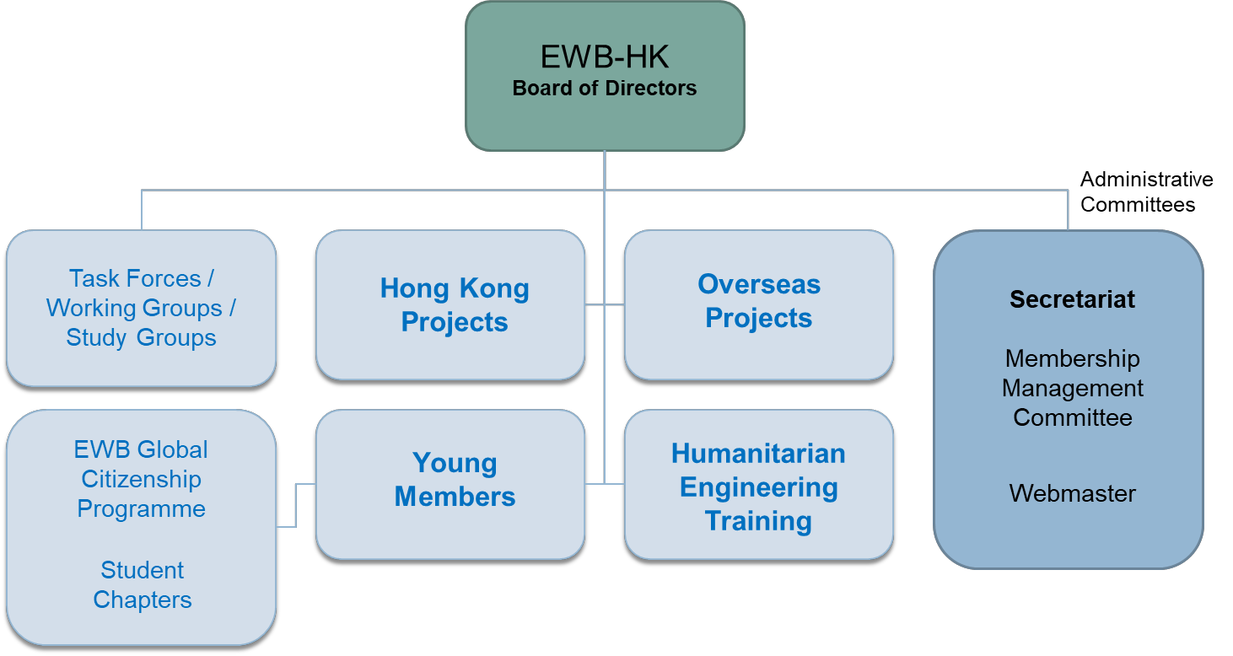

**3.2 Board of Directors**

The Board of Directors (BoD), as the governing body of the Organization, generally manage and conduct the affairs and operation of the Organization. The BoD is composed of persons elected by EWB-HK in accordance to its Articles of Associations and it consists of not fewer than three (3) and not more than fifteen (15) Directors.

Within the BoD, the following offices are nominated:

(a) Chairman;

(b) Vice-Chairman(s) (consisting of the first Vice-Chairman and a maximum of 2 others)

(c) Secretary;

(d) Treasurer;

(e) Directors;

Each Director remains serves for a term of 2 years. After completion of this period a Director is eligible for re-election.

Directors are elected during alternate Annual General Meetings (i.e. once every two years).

Candidates for the office of Director need to have been members of EWB-HK for at least 3 years and need to be nominated by a Director other than the candidate himself and seconded by two other Directors at least 10 days before the General Meeting at which he/she is proposed to be elected.

Directors appoint a Chairman and up to 3 vice-chairmen among their midst.

A Director shall vacate office:-

* 1. (a)  if a receiving order is made against him or he/she makes any arrangement or composition  with his creditors; or
  2. (b)  if he/she dies or becomes of unsound mind whilst in office; or
  3. (c)  if by notice in writing to the Organization he/she resigns his office; or
  4. (d)  if ceases to be a Member of the Organization;
  5. (e)  if he/she is incapacitated for a substantial period; or
  6. (f)  if he/she is removed from office by a resolution duly passed at an Extraordinary General  Meeting specially convened for such purpose.

Current Board of Directors' names and positions are included in Appendix 3.2.1 - Board of Directors

The Articles of Association for EWB-HK is documented in Appendix 3.2.2

**3.3 Committees**

The Board of Directors may delegate any of its powers to committees consisting of such member or members and the powers so delegated conform to any regulation that may be imposed on it by the Board of Directors.

A chairman of each committee is appointed directly by the BoD.

If at any meeting the chairman is not present, the members of the committee present may choose one of their numbers to be standing-chairman of the meeting.

One or more vice-chairman can be appointed exactly for this purpose.

It is a EWB-HK requirement that all office bearers within a Committees must be official Members of the Organization.

Non-member volunteers can also operate within the framework of a committee but they cannot be appointed to any formal office.

A committee may meet and adjourn as it thinks proper. It should fulfil its intended goal and vision and periodically report to the BoD about the status of its operations and members.

Presently operating committees are further discussed in section 5 through 10 of this Manual.

For further information on the Executive Committees structure, please refer to Appendix 3.3.1 - Structure of Executive Committees.

**3.4 Membership**

Members of EWB-HK are individuals who have contributed substantially in promoting and expediting the objects of the organization. They function for all ordinary matters as the "shareholders" of the organizations and they fulfil the key roles within EWB-HK. All directors and chairs are therefore necessary members of EWB-HK.

All members are entitled to the following rights and privileges:

* + (a)  to elect and be elected to the Board of Directors;
  + (b)  to attend, participate in and vote at General Meetings;
  + (c)  to participate in all activities and functions organized by the organization;

All Members shall fulfil the following obligations:

* (a) abide by the Articles of Association and resolutions of the Organization;
* (b) pay Membership Fees, Annual Subscriptions (if any) and other fees or monies payable to the Organization.

New Members may be invited from time to time by the Board of Directors to join EWB-HK. New applicants shall submit to the BoD a written application. The BoD may reject or approve this application.

Membership of the Organization can be terminated: -

* (a)  on receipt by the Secretary of an one month's written notice, or
* (b)  in default in the payment of Membership Fee or Annual Subscription or other fees or  monies payable to the Organization for more than six months,
* (c)  by giving 7 days’ notice to the organization in writing.

The Board of Directors may from time to time determine the amount of the Membership Fee to be paid upon admission to membership (if any) and the amount of Annual Subscription (if any).

More information on the membership protocol can be found in Appendix 3.4.1 - BoD Notice on Membership.

**3.5 Volunteers**

Volunteers are recruited by EWB-HK to do humanitarian and non-profit work in Hong Kong or abroad.

Volunteers act on a non-profit basis and according to their skill set. They are assigned to teams or workgroups and supervised by EWB-HK members and/or committees.

Volunteers are required to abide by EWB-HK code of conduct.

Any individual older than 18-years-old can become a volunteer of EWB-HK by filling a form on the EWB-HK website. Upon submission of this form, a member of EWB-HK will contact the aspiring volunteer to assign work.

Volunteers are not members of EWB-HK and as such they do not share members’ duties and privileges, namely they do not attend the Yearly General Meeting and they have no right of vote for any office.

**3.6 Staff**

EWB-HK may recruit full-time or part-time paid staff to attend to specific matters.

Staff recruitment needs to be proposed by Chairman and approved by the majority of BoD before any interview process is initiated.

No present or past Director of EWB-HK can be qualified as a paid staff and no Director can perceive a salary from EWB-HK. Out-of-pocket expenses for matters related to the Organization can of course be reimbursed to Directors.

Present or past members of EWB-HK can be recruited as paid staff.

Members will have to undergo due process of interview and no preference will be given to members.

No discrimination of gender, race, age or nationality will be made upon recruiting staff.

* 1. **Advisers**

The Board of Directors may invite any person or persons whether Members or non-Members to become Honorary Advisers of the Organization from year to year.

The Honorary Advisers shall not make payment of any fee or subscription. Any person who has accepted the office of an Honorary Adviser may relinquish it at any time, upon written notice being given to the Board of Directors.

Advisers have all rights and duties as ordinary members and their vote will be admitted during Yearly General Meetings.

# **SECTION 4: CODE OF CONDUCT**

EWB-HK is an organization of like-minded people who share a common vision, and embark on a common mission. This group has decided to put aside their political differences, religious beliefs and personal financial interests to come together to pursue the common vision.

The Engineers Without Borders (Hong Kong) Limited Handbook attempts to lay out in specific behaviours to be agreed by all those who volunteer to take part to work in EWB-HK’s missions or take part in its activities.

For details, please refer to the Handbook in Appendix 3.5.1 EWB-HK Handbook (Eng) and 3.5.2 (Chinese version)

# **4.1 Introduction**

This code of conduct applies to all members who work for EWB-HK, regardless of rank or level, board director, ordinary member, volunteer, part-time or full-time, here in after collectively referred to as ‘Personnel’. Where specific policies apply only to a specific group or role, it would be explicitly mentioned in the document.

EWB-HK undertakes to build up responsible and independent governance mechanisms and appropriate human resource capacity and capability to deliver our work and value. However, it is as equally important as for each personnel in EWB-HK to manifest the value and spirit of our mission via action and behaviour.

# **4.2 Breach of code**

Any violation of the Code of Conduct must be reported to the Person-in-Charge (PIC) appointed by the EWB-HK Board of Directors, or the partner hosting NGO to take appropriate action. Personnel must report any form of discrimination, retaliation or harassment, including sexual or gender harassment, and any form of sexual exploitation and abuse.

EWB-HK and personnel are obliged to cooperate with any duly authorised audits and investigations.

If personnel are found to have acted in breaching of the code, EWB-HK will take appropriate enforcement measures against the related personnel, depending on the severity of the action, up to and including revocation of membership.

If, after proper investigation, there are credible allegations of serious misconduct, these cases may, upon consultation with EWB-HK Legal Adviser, be referred to local authorities.

# **4.3 Principles ­­**

## Humanitarian imperative comes first.

## The right to receive humanitarian assistance, and to offer it, is a fundamental humanitarian principle which should be enjoyed by all citizens of all countries. Personnel recognises the obligation to provide humanitarian assistance wherever it is needed.

## Uphold the standard.

## Personnel shall uphold and promote the highest standards of ethical and professional conduct as well as values, including and not limited to honesty, transparency, commitment, engagement, solidarity, efficiency, competence and integrity.

## Personnel shall always act with care. While EWB-HK welcomes any form of support provided from our personnel, personnel shall acknowledge their competence in specific areas and perform service according to their competence.

## Unless personnel are designated to take control of the project, personnel shall never affix their signatures to any plans or documents. Personnel shall advise the beneficiaries truthfully about the progress of the project, or whether the project would be successfully completed.

## Personnel shall avoid the use of statements containing material misrepresentation of facts or omitting a material fact.

## Personnel shall acknowledge their errors and shall not distort or alter the facts.

## Personnel shall follow the instructions of the team leader designated by EWB-HK and not pursue private interests.

## Personnel should raise a concern about a danger, risk, malpractice or wrongdoing which affects others, and support other personnel to raise the concern.

Given they have evaluated their competency, Personnel is entitled to review and evaluate the work of others when required so. However, any form of appropriate suggestion is encouraged.

Personnel is encouraged to share their technical knowledge, idea and expertise with other personnel within the project.

Personnel shall not use their function in EWB-HK or knowledge obtained from EWB-HK for the private benefit of him/herself or others, nor to the detriment of others.

While EWB-HK pays the highest respect to personnel’s religious and political value, personnel is expected to put aside their political differences, religious beliefs and personal financial interests to come together to pursue the shared vision.

Personnel shall guide by the motivation to devote our knowledge and abilities without regard to financial remuneration or other financial interest.

Personnel should not abuse his/her connection with other institution outside EWB-HK.

EWB-HK may sometimes act as an institutional link in the partnership between those who wish to assist and those who need assistance. We, therefore, hold ourselves accountable to both constituencies.

We recognize the need to report on our activities, both from a financial perspective and the perspective of effectiveness. We recognize the obligation to ensure appropriate monitoring of aid distributions and to carry out regular assessments of the impact of disaster assistance.

## Equality

## Personnel shall uphold, respect and be loyal to the principles set out in the UN Millennium Development Goals, UN Universal Declaration of Human Rights, and the Earth Charter, the dignity and worth of the human and the equal rights of men and women.

## Consequently, personnel will show respect for all person equally and shall not discriminate against any individual or group of individuals.

## Personnel is expected to act with tolerance, sensitivity and respect for differences. Any form of prohibited conduct in the workplace or in connection with work is a violation of these principles and may lead to disciplinary action, whether the prohibited conduct takes place in the workplace, in the course of official travel or an official mission, or in other settings in which it may have an impact on the workplace.

## Personnel is obliged to ensure that they do not engage in or condone behaviour which would constitute prohibited conduct with respect to their peers, supervisors, supervisees and other persons performing duties for EWB-HK.

## Respect for the community

Personnel shall respect the local dietary practices and make every effort to deal with any differences.

Personnel shall endeavour to respect the culture, structures and customs of the communities and countries. Personnel will respect the local norm on dress code and avoid inappropriate dressing.

Personnel shall portray an objective image of the humanitarian situation where the capacities and aspirations of victims are highlighted, and not just their vulnerabilities and fears.

We recognise the crucial role played by women in disaster-prone communities and will ensure that this role is supported, not diminished, by our aid programmes.

## Indiscriminate Aid

The priority of Humanitarian aid shall be given on the basis of need alone. Personnel shall provide humanitarian aid regardless of the race, colour, gender, language, religion, political views, nationality, ethnicity, sexual preference or status and without adverse distinction of any kind.

Provision of aid will reflect the degree of suffering it seeks to alleviate. Wherever possible, we will base the provision of aid upon a thorough assessment of the needs of the recipients and the local capacities already in place to meet those needs. Within the entirety of our programmes, we will reflect considerations of proportionality.

Personnel must not tie the promise, delivery or distribution of assistance to the embracing or acceptance of any political or religious creed or any interest.

Every humanitarian aid provided by personnel is not a partisan nor political act and should not be viewed as such.

Personnel should not allow external or internal demands for publicity to take precedence over the principle of maximising overall relief assistance.

EWB-HK will avoid competing with other disaster response agencies for media coverage in situations where such coverage may be to the detriment of the service provided to the beneficiaries or the security of our staff or the beneficiaries.

## Sustainability

Where possible, personnel should always work through local partners at the planning and implementation stages, employing local staff, purchasing local materials, trading with local companies and cooperating with local government structures where appropriate.

Effective relief and lasting rehabilitation can best be achieved where the intended beneficiaries are involved in the design, management and implementation of the assistance program. EWB-HK strives to achieve full community participation in our relief and rehabilitation programs, which actively reduce the beneficiaries’ vulnerability to future disasters and help create sustainable lifestyles.

Personnel should pay particular attention to environmental concerns in the design and management throughout the project, endeavour to minimise the negative impact of humanitarian assistance, seeking to avoid long-term beneficiary dependence upon external aid, and minimise the wasting of valuable resources.

# Avoid personal liabilities

Personnel must comply with local laws and honour our private legal obligations.

While working on the overseas project, personnel must always be careful not to contravene any local law. Offenders are responsible for their legal liabilities.

EWB-HK will do its best to assist personnel if accidents are encountered that may cause harm to people or property damage during a mission. However, personnel must acknowledge that EWB-HK is not liable for any such loss.

Before engaging in overseas missions, personnel is warmly advised purchasing dedicated travel insurance to cover any personal damage or loss.

## Avoid conflicts of interest

Personnel shall fully disclose conflicts of interest to the appropriate party in any extent.

Personnel shall seek consultation and direction from responsible personnel in EWB-HK before engaging in activities that may place them in a position of conflict of interest.

EWB-HK’s work does not require any form of reward or pay.

Personnel should refrain from accepting any compensation or reward from the recipients of EWB-HK's work.

EWB-HK will never knowingly – or through negligence – allow personnel to be used to gather information of a political, military or economically sensitive nature for governments or other bodies that may serve purposes other than those which are strictly humanitarian, nor will act as instruments of foreign policy of donor governments, nor will act as instruments of foreign policy of the governments.

Personnel shall also not to use positions, material or resource in EWB-HK to run for public office, promote a particular political party or religion.

1. Condemnation of sexual abuse

Sexual exploitation and sexual abuse violate universally recognised international legal norms and standards and therefore constitute acts of serious misconduct.

Personnel must not engage in any form of harassment as well as all forms of sexual exploitation and abuse.

For the protection of all parties involved, the following specific standards are promulgated:

1. Sexual activity with children (persons under the age of 18) is prohibited regardless of the age of majority or age of consent locally. Mistaken belief in the age of a child is not a defence.
2. Exchange of money, employment, goods or services for sex, including sexual favours or other forms of humiliating, degrading or exploitative behaviour, is prohibited. This includes any exchange of assistance that is due to the beneficiaries.
3. Sexual relationships between EWB-HK personnel and beneficiaries of assistance undermine the credibility and integrity of the work of the EWB-HK and are strongly discouraged.
4. Where Personnel develops concerns or suspicions regarding sexual exploitation or sexual abuse by a fellow worker, whether in the same agency or not and whether or not within the EWB framework, he or she must report such concerns via established reporting mechanisms.
5. Personnel is obliged to create and maintain an environment that prevents sexual exploitation and sexual abuse. Managers at all levels have a particular responsibility to support and develop systems that maintain this environment.

The standards set out above are not an exhaustive list.

Other types of sexually exploitative or sexually abusive behaviour may be grounds for administrative action and/or disciplinary measures, including summary dismissal, pursuant to EWB-HK conditions of deployment.

Personnel shall be treated with dignity and respect and to work in an environment free from prohibited conduct as described above.

**SECTION 5: HONG KONG PROJECTS COMMITTEE**

**5.1 Description and General Information**

The Hong Kong Projects Committee (HKPC) was officially formed in February 2017.

The Committee aims to provide a service project platform in Hong Kong and to fill up the technical gaps in the local social services sector. The extent of beneficiaries through our service projects ranges from the local communities in need, social services organizations to individual disadvantaged people.

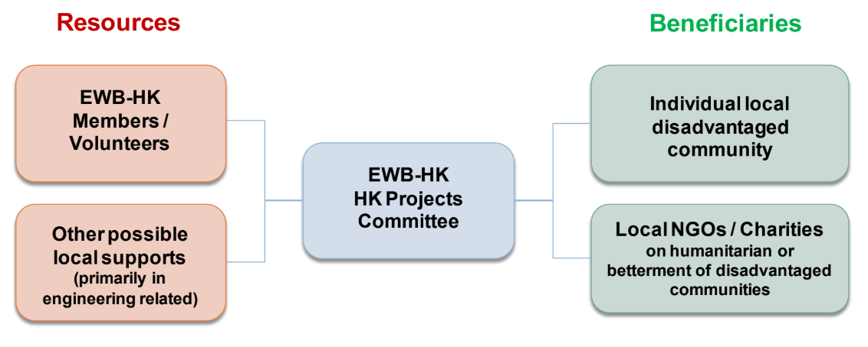

# **5.2 Objectives**

1. To set up a platform to bridge the beneficiaries and competent volunteers;
2. To provide direct and indirect engineering supports to the beneficiaries;
3. To provide engineering support to the communities with emergency technical needs

# **5.3 Core Values**

Quality, Teamwork, Social Bonding, Connecting with Stakeholders

# **5.4 Structure**

HKPC is led by a Committee Chairman, directly appointed by EWB-HK Board of Directors. The appointment remains effective until Chairman resigns or is replaced by the Board of Directors, via written notification. Committee Chairman determines the composition of the Committee and the Committee members and officers. Among these he/she shall appoint a group of volunteer, including:

1. General Secretary
2. Financial Secretary
3. Relationship Manager

Roles of major positions are defined as following:

Chairman 1. Overall leadership of the Committee

2. Develop and maintain Committee Annual Plan

3. Supervise overall operations to fulfil missions and objectives of the Committee

General Secretary 1. Convene Committee meetings

2. Maintain and update Committee Member list, CV of instructors, trainers, advisors, etc.

3. General Secretarial work

4. Ensure compliance to the Personal Data (Privacy) Ordinance

Financial Secretary 1. Keeping full and accurate records of all financial transactions for the Committee

2. Present a full financial report in EWB-HK Annual General

Meeting

3. Manage sponsorship and donations

4. Effect payments on behalf of the committee

The updated HKPC Committee Members List with relative functions is in Appendix 5.4.1

# **SECTION 6: OVERSEAS PROJECTS**

**6.1 Description and General Information**

The Overseas Projects Committee (OPC) was officially formed in January 2018.

The Committee is a group of members/ volunteers that aim to provide a service to overseas disadvantaged communities by filling up the technical gaps between the social services and the direct beneficiaries.

For the overseas projects, EWB-HK typically builds partnerships with other Hong Kong and/ or overseas Partners to accomplish selected missions.

**6.2 Objectives**

1. Assist disadvantaged communities by empowering them with engineering solutions on a non-profit making basis
2. to work in partnership with developing communities, assisting them in gaining access to knowledge, resources and appropriate technologies they need to improve their livelihood
3. to pursue promotion of sustainable development in conformance of the UN Sustainable Development Goals
4. to provide engineering and technical support to charitable and non-governmental organizations with similar objects
5. to prepare Hong Kong professional with a Humanitarian Training by being a "learning organization"

**6.3 Core Values**

* + Support other organizations on technical and management aspects
  + Technology and skill transfer to local communities
  + Humanitarian training for the Engineers
  + Assist communities in attaining United Nations (UN) sustainable development goals
  + Community building through sustainable engineering developments
  + Cultural understanding

**6.4 Committee Structure**

OPC is led by a Committee Chairman. This position is appointed directly by EWB-HK Board of Directors. The appointment remains effective until Chairman resigned or is replaced by the Board of Directors, via written notification.

Committee Chairman determines the composition of the core Committee and the core Committee Members. Among these he/she may appoint other officers such as:

1. General Secretary
2. Financial Secretary
3. Volunteer Coordinator
4. Advisors

Roles of major positions are defined as following:

Chairman 1. Overall leadership of the Committee

2. Develop and maintain Committee Annual Plan

3. Supervise overall operations to fulfill missions and objectives of the Committee

General Secretary 1. Convene Committee meetings

2. Maintain and update Committee Member list, CV of instructors, trainers, advisors, etc.

3. General Secretarial work

4. Ensure compliance to the Personal Data (Privacy) Ordinance

Financial Secretary 1. Keeping full and accurate records of all financial transactions for the Committee

2. Present a full financial report in EWB-HK Annual General

Meeting

3. Manage sponsorship and donations

4. Effect payments on behalf of the committee

The OPC is structured to focus on 5 main functional objectives:

1. Community Housing & Community Development
   1. To improve living condition of community by infrastructure and building construction technics
2. School & Children Center Facilities Enhancement
   1. To improve living condition of school and children center by repair and minor works services
3. WASH (Water, Sanitation, Hygiene)
   1. To share new ideas and practices with NGO or community in WASH
   2. To raise awareness and empower the NGO on Public Health
   3. To reduce WASH-borne disease by empowering the community on WASH utilization
   4. To understand basic needs and cultural practices of WASH through community engagement
4. Urban Sustainability Team
   1. To empower the NGO capacity on improving cultural, environmental and architectural heritage preservation to livable city
5. Youth Education Team
   1. To provide professional vocational education and skills training to the Youth
   2. To raise safety and personal health awareness of youth
   3. To encourage the youth participation at society with engineering knowledge and skills
   4. To enhance knowledge transfer of modern technology to the youth
   5. To provide training to NGO and children development center to enhance their capacity on engineering application

The updated OPC Committee Members List with relative functions is in Annex 6.4.1

# **SECTION 7: HUMANITARIAN ENGINEERING TRAINING**

**7.1 Description and General Information**

The Humanitarian Engineering Training Committee (HETC) was officially formed in February 2017. Its missions are to accelerate betterment in life of disadvantaged communities and provide sustainable development, through people-oriented and strength-based training approaches. These are in line with the missions of EWB-HK.

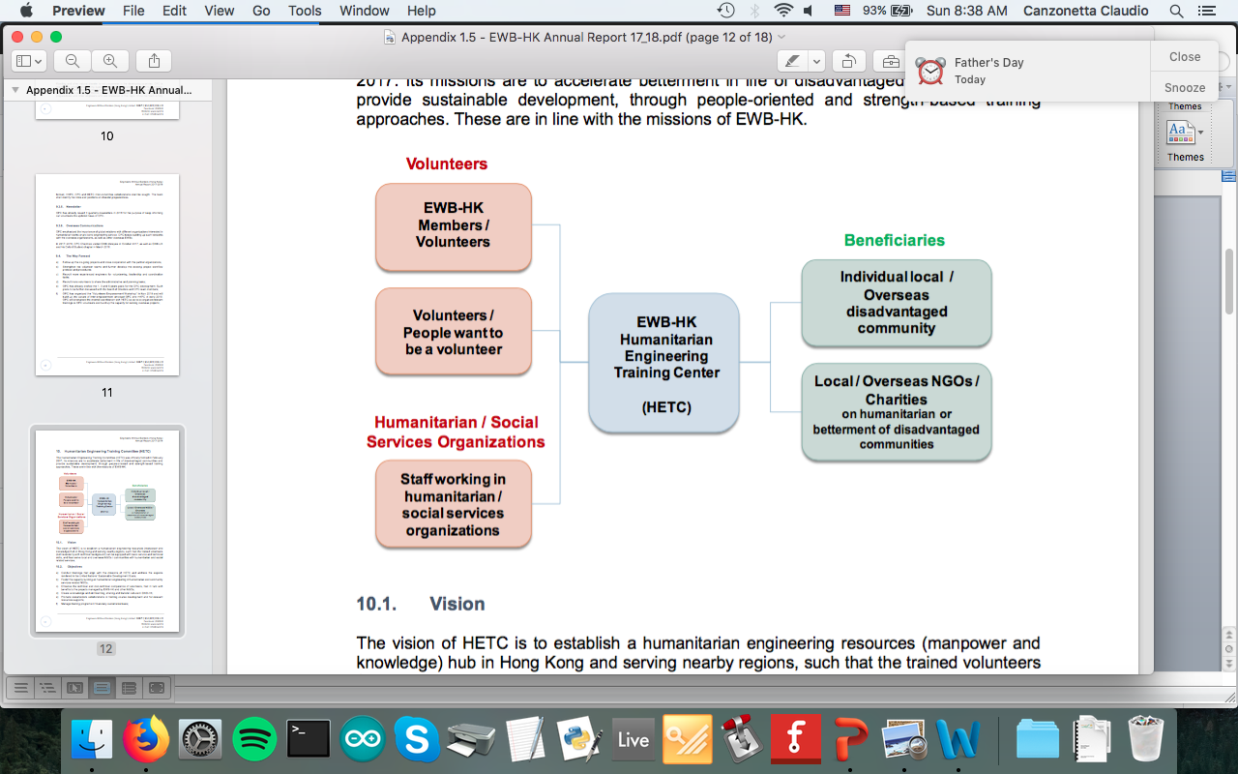

The vision of HETC is to establish a humanitarian engineering resources (manpower and knowledge) hub in Hong Kong and serving nearby regions, such that the trained volunteers (not necessarily with technical background) can be equipped with basic service and technical skills, and then serve local and overseas NGOs / communities with humanitarian and social related services.

**7.2. Objectives**

a)  Conduct trainings that align with the missions of HETC and address the aspects rendered in the United Nations’ Sustainable Development Goals;

b)  Foster the capacity building on humanitarian engineering in humanitarian and community services related NGOs;

c)  Enhance the technical and non-technical competence of volunteers, that in turn with benefits to the projects managed by EWB-HK and other NGOs;

d)  Create a knowledge and skill learning, sharing and transfer culture in EWB-HK;

e)  Promote stakeholders collaborations in training course development and for relevant resources supports;

f)  Manage training programs in financially sustainable basis;

**7.3. Core Values**

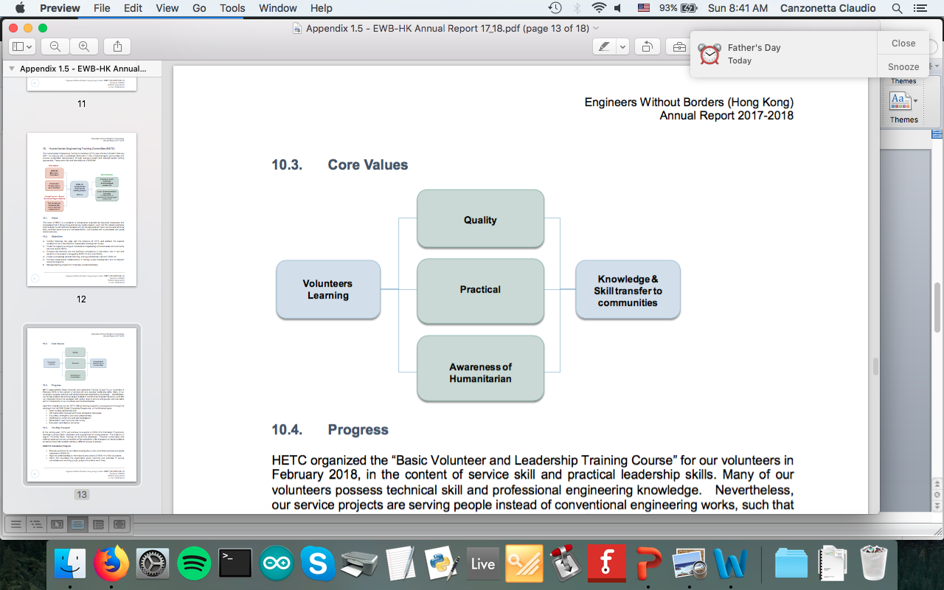

**7.4 Committee Structure**

Humanitarian Engineering Training Committee (HETC) is led by a Committee Chairman. This position is appointed directly by EWB-HK Board of Directors. The appointment remains effective until Chairman resigns or is replaced by the Board of Directors, via written notification.

Committee Chairman determines the composition of the Committee and the Committee Members. Among these he/she shall appoint a Committee Secretary and a Treasurer.

Roles of these position are defined as following:

Chairman 1. Overall leadership of the Committee

2. Develop and maintain Committee Annual Plan

3. Supervise overall operations to fulfil missions and objectives of the Committee

Secretary 1. Convene Committee meetings

2. Maintain and update Committee Member list, CV of instructors, trainers, advisors, etc.

3. General Secretarial work

4. Ensure compliance to the Personal Data (Privacy) Ordinance

Treasurer 1. Keeping full and accurate records of all financial transactions for the Committee

2. Present a full financial report in EWB-HK Annual General Meeting

3. Manage sponsorship and donations

4. Effect payments on behalf of the committee

The updated HETC Committee Members List with relative functions is in Annex 7.4.1

# **SECTION 8: YOUNG MEMBERS GROUP**

**8.1 Description and General Information**

Young Members Group (YMG) Committee was inaugurated on 21 October 2011.  The first YMG was formed by students from the University of Hong Kong (HKU) and fresh graduates from the City University of Hong Kong (CityU). The provisional student chapter of the Hong Kong University of Science and Technology (HKUST) was formed in April 2013.

YMG is a platform to gather young persons and students to organize activities in line with our missions. In these few years, YMG has been successfully developed and completed several self-financed engineering-based service trips in the Mainland China and Cambodia.

YMG's slogan is "Enlightened with Engineering, Serve the Community".

Its missions are to:

* Create a sense of excitement and enthusiasm about solving technical development problems within cultural and social context.
* Work with EWB-HK to transfer appropriate technologies to the community.
* Encourage young generation to put the missions of EWB-HK into practice.

**8.2 Objectives**

1. Recruit members and volunteers in tertiary educational institution.
2. Connect with student chapters of overseas EWBs.
3. Cooperate with tertiary educational institutions to promote the works of EWB-HK.
4. Cultivate the leadership and spontaneity of students.
5. Participate in the activities organized by EWB-HK.
6. Promote practical application of engineering knowledge amongst students.
7. Coordinate and review joint student chapter or partnering projects and activities.
8. Provide guidance and mentoring support to Student Chapters to enrich their individual potential and team development.
9. Develop relationships with faculties of tertiary educational institutions, professional and institutional partners.
10. Assist in locating potential funding sources.
11. Assist in strategic planning for YMG.
12. Promote and spread the spirit and activities of YMG among institutions.
13. Review and endorse the annual plans as proposed by student chapters.
14. Endorse the annual appointment of student chapter’s committee.

**8.3 Core Values**

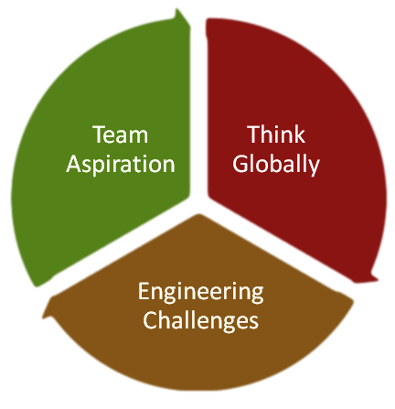

**8.4 Committee Structure**

YMG is led by a Committee Chairman. This position is appointed directly by EWB-HK Board of Directors. The appointment remains effective until Chairman resigns or is replaced by the Board of Directors, via written notification.

Committee Chairman determines the composition of the Committee and the Committee Members. Among these he/she shall appoint a Committee Secretary and a Treasurer.

Roles of these position are defined as following:

Chairman 1. Overall leadership of the Committee

2. Develop and maintain Committee Annual Plan

3. Supervise overall operations to fulfill missions and objectives of the Committee

Secretary 1. Convene Committee meetings

2. Maintain and update Committee Member list, CV of instructors, trainers, advisors, etc.

3. General Secretarial work

4. Ensure compliance to the Personal Data (Privacy) Ordinance

Treasurer 1. Keeping full and accurate records of all financial transactions for the Committee

2. Present a full financial report in EWB-HK Annual General Meeting

3. Manage sponsorship and donations

4. Effect payments on behalf of the committee

**8.5 Global Citizenship Program**

The UN Sustainable Development Goals have provided a key challenge for todays engineers in a humanitarian, ethical and technical perspective. The education of the engineer is very heavily focused on the technical aspects. The challenge now is to develop in our young engineers the social responsibility to strive for sustainable human development, the UN SDG’s and all Global Challenges.

Engineers, who possess technological solutions to global development problems and challenges, play an important role in promoting sustainable development and implementing innovative solutions. The **EWB-HK Global Citizenship Program** creates a real and transformative experience by envisaging engineering and science students to commit themselves in building a sustainable world with engineering solutions and becoming our future global leaders in sustainable development.

The program offers a real and transformative experience to plan and implement solutions to engineering based projects to achieve the SDG’s. The GCP Program Goal is to provide a platform for future engineering leaders to explore the global challenges, to serve the society proactively with global vision, to contribute to the sustainable development goals as global citizens.

The Program Approaches Awareness Building, Community Services, Capacity Building, Appropriate Technology, Network Building.

It delivers experiences through 7 Workshops; 2 Local Community Service Excursions; 1 International (Myanmar) Excursion; and a Post Trip Evaluation/Ideation Workshop. The program is also supported by an Industry Mentorship program. The outcome of the program is the **“Change”** of young engineers in the sense of global citizenship. They advance from a conventional engineer to being an engineer with global vision, capable to embrace cross-discipline collaboration.

Details on the EWB-HK Global Citizenship Program can found in Appendix 8.5.1 GCP19 Program

# **SECTION 9: STUDENTS CHAPTERS**

**9.1 Description and General Information**

Student chapters are group of students coming from tertiary educational institutions in Hong Kong that refer to YMG Committee for their assembling and daily operation.

Their relationship with YMG is exemplified by the following diagram:

**9.2 Objectives**

1. Support the values and missions of EWB-HK
2. Provide chapter leadership and maintain a healthy chapter operation.
3. Raise awareness of development issues among members and volunteers, as well as to offer the opportunities to solve   technical problems for the communities in need.
4. Foster cultural understanding and awareness among students.
5. Provide training to students to become internationally responsible engineer.
6. Help disadvantaged communities meet their basic needs.
7. Offer supports to the projects activities and operation of EWB-HK, i.e. supports means involvement in promotion, front line   assistance etc.
8. Actively participate in the activities and projects organized by EWB-HK and YMG

**9.3 What does a Student Chapter do**

1. Attracts new members.

a. The chapter provides a means for new students of all disciplines to help make a

difference.

b. EWB is open to engineering students and non-engineering students alike.

1. Holds chapter meetings once a month or as necessary (individual project meetings will most likely meet several times per week).
2. Provides training for other students.
3. Finds and applies for projects via EWB-HK (see section 13 for details).
4. Forms sub-committees to work on those projects.

**9.4 How to start a Student Chapter**

Before starting a chapter, it is necessary to have in place:

1. A driven leader: This person can either be a faculty member or a student.
2. A few excited students: we recommend a minimum of 3 people for each chapter.
3. Faculty support: We have found that having a faculty member, and/or the Dean behind the chapter, provides continuity and guarantees official support.

Once enough people are interested in starting a Student Chapter, the next step is to contact EWB-HK, namely the Young Member Group, which will operate as a reference for all Student Chapters.

EWB-HK will provide information on how to formally start the Chapter and will require each chapter to submit a formal Student Chapter Startup Form (Appendix 9.4.1).

The Form should be submitted at the beginning of each school year.

**9.5 Student Chapters Structure**

Each student chapter must have at least an energetic leader who is willing to put enough time to make the Chapter successful. This leader is nominated President of the Chapter.

Each chapter must have a President. If other strong-willed individuals are willing to help the President managing the Chapter, they can be nominated Deputy Presidents of the Chapter.

Other officers may include a Secretary and a Treasurer, to the President discretion and based on the size of the Chapter. The only mandatory officer for each chapter is the President.

All officers remain in power for the entire student year and can be replaced for the next year, upon submission of a new Startup Form.

Representation of each Students Chapter is assured via a Standing Committee, which interacts directly with EWB-HK and includes representatives from all Student Chapters in Hong Kong.

The Standing Committee is formed by:

* + Student Chapter Representatives
  + Ex Student Chapter Representatives
  + Graduate Volunteers

The seats on the committee are assigned as following:

|  |  |  |
| --- | --- | --- |
|  | Student Chapter Representative | Ex-Student Chapter Committee & Graduate Member |
| 1st Institution | X1 | Y1 |
| 2nd Institution | X2 | Y2 |
| nth Institution | Xn | Yn |
| No of standing committee from each institution | X + Y = 4  *There will be 4 seats in Standing Committee for each institution. | |
| Total no. of Standing committee in YMG | 4n | |

Function of the student chapter representatives are as following:

|  |  |  |  |
| --- | --- | --- | --- |
|  |  | **Mentor** | **Functional** |
| **Standing**  **Committee** | Student chapter Representatives | ***-*** | ***√*** |
| Ex-Student chapter Committees | ***√*** | ***√*** |
| Graduate volunteers | ***√*** | ***-*** |
| **Sit-in member** | EWB-HK council members | ***√*** | ***√*** |

Representatives have right of vote and both functional and mentoring duties and they report directly to the YMG Committee.

# **SECTION 10: PROFESSIONAL CHAPTERS**

**10.1 Description and General Information**

Professional Chapters are group of professionals who are willing to work together mentoring and assisting University students in carrying out EWB projects.

The model for Professional Chapters is shown below:

University Education, Technology, Training, Diversity

**Implementation:**

**Cultural Awareness, Hands-on Experience, Case Studies**

**EWB**

**Project**

Students

Professionals

While university engineering programs focus on academic student education and research, professional chapter activities will focus on the **provision of mentorship**, **training**, and **field experience** to the student chapters.

This type of partnership results in environmentally and economically sustainable projects that are compatible with the environment, society and the culture of disadvantaged communities. We believe that professional/student partnering will develop a new generation of engineering students, who will benefit from seeing the many facets of engineering solutions to problems in developing communities, beyond the technical skills obtained in their curriculum – and in the education of host-community partners

Professionals are not limited to engineers, but also surveyors, scientists, social workers, and all other professionals that can help us to deliver the services to the local community and partner communities. Students are involved in every step of the process, enabling them to learn first-hand about solutions to the problems of the developing world.

**10.2 Objectives**

1. To assist in training a new generation of professionals through the mentorship of student chapters in new and on-going national and international development chapters. Each Professional Chapter is asked to “adopt” a student chapter if possible.
2. To contribute to new and on-going development projects, promote high engineering standards, and to expand the dimensions of experience for emerging and practicing engineers.
3. To provide technical resource for students of all levels.
4. To collect and provide research on sustainable technologies to create internationally responsible engineers.
5. To maintain a presence in the local community through service.
6. To inspire with word and action a new generation of students towards humanitarian work

**10.3 What does a Professional Chapter do**

1. Provides technical and mentoring assistance to student chapters.
2. Attracts new members.

a. The chapter provides a means for new professionals of all disciplines to help make a difference.

b. EWB is open to engineering professionals and non-engineering professionals alike.

1. Works on Professional Members Projects.
2. Holds meetings once a month or as necessary.
3. Provides training for students and other professionals.
4. Acts as a technical resource.
5. Finds and applies for projects.
6. Forms sub-committees to work on projects.

**10.4 How to start a Professional Chapter**

Before starting a chapter, it is necessary to have in place:

1. A driven leader.
2. Some motivated professionals with enough time to dedicate to this project: we recommend a minimum of 3 people for each chapter.

Once enough people are interested in starting a Professional Chapter, the next step is to contact EWB-HK, namely the Hong Kong Project Committee, which will operate as a reference for all Professional Chapters.

EWB-HK will provide information on how to formally start the Chapter and will require each chapter to submit a formal Professional Chapter Startup Form (Appendix 10.4.1).

The Form should be submitted at the beginning of each school year.

**10.5 Professional Chapters Structure**

Each Professional Chapter must have at least an energetic leader who is willing to put enough time to make the Chapter successful. This leader is nominated President of the Chapter.

Each chapter must have a President. If other strong-willed individuals are willing to help the President managing the Chapter, they can be nominated Deputy Presidents of the Chapter.

Other officers may include a Secretary and a Treasurer, to the President discretion and based on the size of the Chapter. The only mandatory officer for each chapter is the President.

All officers remain in power for the entire student year and can be replaced for the next year, upon submission of a new Startup Form.

Representation of each Professional Chapter is assured via an Executive Committee, which interacts directly with EWB-HK and includes representatives from all Professional Chapters in Hong Kong. Each Chapter authorizes a maximum of 4 representatives to join the Executive Committee, so the total number of members of the Executive Committee is 4n (with n being the number of Professional Chapters).

SECTION 11: TRAVEL

**11.1 Travel Safety and Health Procedures**

Prior to finalizing your group’s travel plans, each member of the group should do the following:

1. Fill out the Travel Team Checklist (Appendix 11.1.1) and hand it to the project leader.
2. Review the Tips and Recommendations as per Section 11.4 of this Manual
3. Fill out the Health Questionnaire (Appendix 11.1.2) and give it to the health point person (HPP) traveling on the project.
4. Prepare a medical kit using the First Aid Kit Content form (Appendix 11.1.3) as a guideline.
5. Fill out the Responsibility Waiver (Appendix 11.1.4) and send it to the EWB-HK staff prior to travel (should be submitted with the assessment or implementation presentation).
6. Obtain a list of emergency contacts from your Team Leader and make sure the list is packed and always at hand

**11.2 Vaccinations**

All EWB volunteers traveling to a foreign country are expected to get the recommended vaccinations for their travel destination.

Information on these vaccinations can be found at your doctor’s office, travel clinics or through the World Health Organization (WHO) or Centers for Disease Control (CDC).

**11.3 What to do before a trip**

It is suggested that the Project Leader obtain advance information for the specific countries that will be visited. Valuable information on travel safety can be obtained from: Peace Corps offices, Embassy offices, travel agencies, airlines, etc.

Check all customs regulations if bringing in items to the country, especially if your team will be brining expensive items.

Each volunteer and their family need to make an informed decision as to their safety while out of the country.

Checklist of most important items:

* Valid passports
* Visas
* trip insurance
* vaccinations
* health and trip insurance
* medical evacuation insurance
* foreign exchange
* project components packed and ready
* EWB liability waivers in place

The Health Point person should have a completed Personal Health Checklist for each person on the project team, a first aid kit and a list of key contact phone numbers and Embassy Contact number in host country.

The Personal Health Checklist for each person is to be taken on the trip, should a situation arises where this information is needed.

Useful items recommended your team carries on field trip include:

* GPS & hand level
* satellite phones
* first aid and medical supply kit
* list of key contact phone numbers
* Embassy Contact number in host country

Distribute information on location of nearest medical facilities in the field, etc., verify and

distribute emergency contacts and village contacts to all project participants.

Develop an emergency plan and an exit strategy.

Schedule a Travel Readiness Review two to four weeks before the project trip. Verify all team

travel logistics, budgets, and funds.

Provide host country cultural information to trip participants.

Prepare team members for cultural differences - higher population density, fewer comforts of

sanitation, temperature control, etc., and the possibility of seeing people, particularly children and

animals, in dire conditions.

**11.4 What to do during a trip: tips and recommendations**

Make sure that project leaders know always where you are.

Abide at all times to local legislation and to the EWB-HK Code of Conduct.

Make sure all expenses are properly accounted for and receipts are kept.

Refrain from alcohol use and mind altering drugs whether they are legal or illegal in the project country; bribery, culturally inappropriate behavior, and sexual relations with members of the traveling team or partner communities.

Mantain open mindedness and preferably avoid conversations about political, economic, and

religious opinions.

Ask trustworthy partner NGO members upon arrival about common practise and the local safety tips.

Don't bring expensive items or large amount of cash on the trip, use an ATM card or credit card instead if at all possible.

If possible, travel with a locally purchased or rented mobile telephone. These are increasingly available in almost all countries.

Always keep your hotel door locked. Always sleep in locked and secured accommodations.

Look for fire safety instructions in your hotel room.

Always lock your baggage

Keep one hand free to protect yourself and your valuables.

Bring sufficient local currency for daily expense and emergency.

Meet visitors in the lobby.

Inform someone, including the front desk, when you expect to return if you will be out late at night.

Avoid being alone. If absolutely needed, make sure that someone knows where you are and where you will be.

Adhere to advice on districts or regions to avoid

Avoid any item that declares your nationality or political beliefs.

# **SECTION 12: FINANCE/ FUNDING**

**12.1 Description and General Information**

EWB-HK is a nonprofit, humanitarian organization, we rely on the generosity and philanthropy of supporters to fund our work. Donations form a key part of our income which in turn helps us support inspirational community organizations as well as nurturing and empowering future community development professionals prepared to make a difference. The contribution will not only directly support our existing community and educational programs but will help us scale up our efforts to reach further and have greater impact.

All donations, whether via fundraising or grants, are managed by the Financial Team, led by the EWB-HK Treasurer together with all Committees' Financial Directors (if any of them have been appointed).

EWB-HK is a registered non-profit organization (NGO) in Hong Kong and therefore all donations are tax deductible according to Hong Kong S.A.R. legislation. Our Financial Team will be happy to provide receipts for tax deduction purpose.

Donations to EWB-HK from abroad may not be tax deductible in other countries.

**12.2 Types of funding**

EWB-HK receives funds from the following sources:

1. Membership fees and annual subscriptions
2. Donation from members, philanthropic organizations and external individuals
3. Fundraising events
4. Grants

Donations can be processed according to Appendix 12.2.1 "Donation Methods".

**12.3 Fundraising**

Members and volunteers may periodically organize fundraising events to help EWB-HK and other communities. Fundraising ideas can be collected from members and volunteers but they need to be vetted by EWB-HK's Treasurer before any action is taken.

Common ideas for fundraising events are:

1. Convincing a Corporate Donor to join the cause
2. Launch a Fundraising Campaign via online Social Media for a particular project by EWB-HK
3. Organize a local Fundraising Event (party, sport event, etc.)

**12.4 Grants**

Grants from Universities or other Organizations can be applied for, as long as the related funds are deposited onto EWB-HK's official Bank Account and the application is vetted and approved by EWB-HK's Treasurer.

Student Chapters or Committees can propose Grant Applications to BoD or Treasurer for vetting. EWB-HK's Financial Team will perform appropriate due-diligence of grant proposal submitted.

**12.5 General Terms on Funding**

EWB-HK's financial records must pass an annual audit and should follow generally accepted accounting principals, conforming legislation in Hong Kong S.A.R. relative to non-profit organizations.

EWB-HK's reputation and integrity is also at stake, so when unsure always contact EWB-HK's Financial Team for clarification.

Following are some sound principles that should be adhered to:

* all official expenses should be properly filed in the central EWB-HK repository and approved by Financial Team. All filed expenses should use EWB-HK Expense Claim Form (Appendix 12.5.1) and should have attached a proper receipt of the actual expenditure.
* funding must be used according to the original published intent. If funds were raised for a particular project, they can only be allocated for us on that project and cannot be diverted to other general expenditures.
* new funding cannot be used for past expenses (i.e. expenses occurred before the funding was received or to pay off a deficit)
* EWB-HK's Financial Team has the final word on how to manage, hold and administer the funds: even if a Committee has worked on a fundraising events, it is not automatic that the Financial Team will allocate the raised funds to the same Committee.
* There are no exceptions to the deadlines stated in grant award letters. Failure to meet deadlines may result in repayments of the entire grant, therefore members and teams who have been allocated funds will be liable to ensure deadlines are met and funds are used correctly. Sanctions may be levied at EWB-HK's sole discretion, in this case.

SECTION 13: PROJECTS

**13.1 Introduction**

All committees, teams and chapters are involved in projects, jointly or separately.

These are initiated at all levels: from Chapters themselves, or by Committees or even at Board of Directors level.

There are many types of EWB-HK projects, including:

1. Small construction projects: design and construction or repair of community health centers, schools, and shelter systems;
2. Water and sanitation projects: provision of potable water, and wastewater management projects;
3. Renewable energy projects: design and installation of photovoltaic systems, wind, biodiesel.

There are certain fields that EWB-HK will not support:

1. A project that benefits a single person or family;
2. Projects that require fixed salaries, operational costs, or rolling funds for daily functioning
3. Projects with military implications or having solely commercial, religious, or political objectives;
4. Projects involving purchase of vehicles, dynamite, detonators, medicines, or consumable goods not related to construction.

Priority is given to projects that incorporate the following characteristics:

1. The project responds to a need or real problem in the community;
2. In responding to this need, due consideration is given to ensure no unintended damage occurs over the long term to the community structure or to the surrounding environment/ecosystem.
3. The project benefits a significant portion of community members;
4. Commitment of individuals or groups from the community to maintain and assure the continuity of the project (such individuals may receive training from EWB-HK);
5. The community contributes significantly to the execution of the project;
6. The project represents the organization and effort of a collective, and not one single person;
7. The project makes use of technology that is appropriate to the specific community;
8. The project goals are clearly understood by project personnel and realistically achievable.

The following critical issues are addressed when considering a project for EWB-HK participation:

1. Who asked EWB-HK to get involved?
2. Does the project "fit" within the EWB-HK mission, values, and strategic plan?
3. Is the anticipated positive impact of the project on the community quantifiable?
4. Have potential negative impacts been assessed and minimized, both in terms of long-term temporal effects as well as adoption of this technology over a larger spatial scale?
5. Are cultural, environmental and ecosystem considerations included?
6. Is there potential for partnering / teaming with local or regional organizations?
7. Are there local engineers, students, schools, university contacts, project managers / funding agencies to participate or contribute to the project?
8. What is the time frame of commitment to the project and local community?
9. What are the local community’s expectations and contributions for the project?

**13.2 Project Process**

In order to optimize and standardize handling of projects, EWB-HK has created a procedure to plan, manage and execute projects of all types.

The overall procedure could be exemplified by the following Project Step Cycle:

Macintosh HD:Users:canzonettaclaudio:Desktop:Project Cycle Steps.pdf

INITIATE: Identify the Opportunity and get to know each other

1. Project Identification and Background

The starting point of each project is the “5 Ws”: Who, Where, What, When and Why.

At this stage it is useful to clarify each of the 5 W and the project beneficiaries, plus means of delivery and potential partners.

Opportunities are identified and assessed.

An initial Project Introduction may to be prepared at this stage.

1. Partner Due Diligence and Approval

This is a crucial step in the project and EWB-HK has developed tools to ensure we only cooperate with professional partners in a systematic way.

As soon as a partner is identified, the Team Leader is requested to fill in a Partner Evaluation Questionnaire (appendix 13.2.1). For HKPC, use Appendix 13.2.1b 500-HKPC Project Partnering Information Form

The candidate partner will then need to be provided EWB-HK standard Partner Handbook (appendix 13.2.2) and they will need to sign its acceptance, as agreement of the common operating principles during the project.

Both documents will therefore need to be presented to the Committee Chairman for Patrner Approval. A Partner Approval does not ensure automatic Project Approval: only the possibility of cooperation with the candidate partner submitted for evaluation.

For HKPC, please reference sample agreement in Appendix 13.2.2b HKPC Cooperation Agreement Sample

PLAN: Produce a Program Brief (Scope and Deliverables) through collaboration and site investigation

1. Site Investigation and Survey

The subject site is first investigated remotely, via desktop study.

The communities of the site surroundings, the current social, economic, environmental and political situations of the region must be assessed, together with the existing social / community services for the subject site and the communities of the site surroundings.

An on-site investigation trip may be arranged at this point, if deemed necessary.

This has to be approved first by the Committee Chairman.

During the on-site survey trip, site location will be assessed and site communities will be interviewed, together with communities’ leaders. A detailed account of of the surrounding natural environment, infrastructure, social and livelihood provisions will be drafted.

It is recommended to use a GIS-enabled survey App during on-site investigation.

Deliverables from this on-site investigation trip should be all useful data necessary to create a detailed project brief, including maps, data, photos, videos and reference documents.

For HKPC, if feasible reference survey in Appendix 13.2.3b HKPC-Household Safety and Env Survey Form R1

1. Project Brief

The first step towards the creation of a detailed Project Brief is to do a Feasibility Study.

Teams are encouraged to carry out problem-tree analysis, shortlist the problems identified, determine their root causes and problem categorization. This will allow them to identify potential scope of works and prioritize feasible goals, while also pointing out any potential risks.

If the Feasibility Study is positive, the team can proceed to create a formal Project Brief.

This will be useful to establish the project goals, objectives and deliverables, the potential impact to the beneficiaries and the work relation to the UN SDGs.

At this point it is useful to clarify the preliminary timelines of the potential works and to start working on the design inception of the potential works, together with a rough budget of the potential works.

A project team can be proposed at this stage together with a candidate review engineer.

To assist in the creation of this Project Brief, it will be helpful to consult the Project Brief Checklist (appendix 13.2.3)

1. Project Approval and MOU

Once the Project Brief is completed, a formal Project Approval Form (appendix 13.2.4) needs to be filled in by the team and submitted to the Committee Chair together with all of the other documents (Project Brief and Partner Handbook signed).

Documents relative to the project will be reviewed by the Committee and once the project is approved at Committee level, it will need to be endorsed by the Board of Director.

At this point an MOU is signed between EWB-HK and the partner organization.

For HKPC, complete Appendix 13.2.4b 501-HKPC Project Application Form

EXECUTE: Provide detailed drawings and specifications to allow for project execution

1. Design

At this stage the project scopes, design parameters and local technical parameters are updated.

A detailed design is prepared in form of a scheme design (hand sketch or CAD) or reference drawings from other sources, to show the spatial relationship, major dimensions, materials and construction methods.

Relevant technical specifications need to be drafted (local government standards and industry practice shall be given / supported by the local partner).

If applicable, the team creates a preliminary schedule of material quantities and price rate templates (the materials’ unit rate shall be obtained by the local partner in the local market).

1. Tender

The team prepares a simple contract document for tender / quotation seeking (tender / quotation process shall be carried out by the local partner). This will need to include terms and conditions and roles and responsibilities for the project.

Tender can be drafted using the Tender Process Guidelines (Appendix 13.2.5).

Terms and Conditions can be drafted along the form provided in T&C Template (Appendix 13.2.6).

The Tender Process Guidelines make reference to Specifications Divisions (Appendix 13.2.7), which Project Leaders are invited to use as much as possible.

A General Specifications Template (Appendix 13.2.8) is also provided.

Once all documents are drafted, EWB-HK’s local partner will carry out the tender.

All tender submissions will be assessed by EWB-HK’s team and a written recommendation of the appropriate contractor will be submitted to partner approval.

Analysis is based on cost, quality, completeness, past performance, ability to meet schedule, suggestion of alternatives, others.

Once approval is obtained by local partner, all construction drawings, specs, schedule and methodology will be reviewed again with contractor and a formal agreement will be signed between the local partner and the contractor.

**It is important to note that any work done by EWB-HK abroad should be presented as “Reference Only” (for example: “Construction Reference Drawings”), since our members very likely do not have a licence to operate locally during a project trip and we do not want to expose our members to professional liabilities.**

MONITOR: Monitor construction/project progress.

1. Construction Monitoring

Monitoring will be conducted for the most remotely after the project is started, as it is unlikely that the whole project will be conducted during one single service trip.

EWB-HK will be invited to review, comment on, raise issues on projects based on photos and routine reports sent to them by the local partner.

Frequency and terms of this type of reporting should be agreed with the local partner and contractor before leaving the project site. These type of reports can be filed by local partner and contractor using EWB-HK’s Construction Progress Report (Appendix 13.2.9).

EWB-HK personnel will advise their professional opinion to the local partner via Construction Observation Forms (Appendix 13.2.10)

Further on-site construction supervision shall be limited to the agreed times and days with the local partner. The usual practice may be a once-off on-site visit for critical stages of the project co-defined with the local partner and the contractor (ie: foundations, footings, reinforcement stages).

8a. Project Status Report

More thorough reports are sent to EWB-HK upon completion of major parts of the project work. At these points of “substantial completion” EWB-HK will be invited to examine the work (remotely or on-site) and assess any potential deficiency through a Deficiency List (Appendix 13.2.11).

The goal of the Deficiency List production is a thorough comparison of the project achievements with the goals highlighted in the Project Brief and the General Specifications.

CLOSE: Close the project and evaluate.

1. Project Completion

This on-site handover inspection shall be carried out at the completion of the construction work.

Handover inspection shall include visual inspection of the completed provisions to find out whether the completed work is generally complying with the intended design, if construction is of acceptable quality and if the required scope of the work has been met.

A proper Project Close-Out Report (Appendix 13.2.12) is filed after the inspection.

The handover documents shall be inspected.

Construction drawings, materials submissions, test reports, construction method statement, testing and commissioning method statement, as-built drawings, operation and maintenance manuals, as submitted by the local contractors will be reviewed (submissions directly given by the local contractors to EWB-HK Project Team shall NOT be accepted. EWB-HK Project Team shall accept submissions, feedbacks and communication between EWB-HK Project Team and the local partner ONLY)

After witnessing the handover of the completed provisions from the Contractor to the local Partner, Project Team will recommend final payment and attend the handover ceremony (usually organized by local partner)

1. Project Close-out

This is an opportunity to create records from the project, so that they can be used for learning and experience.

Feedback is shared between EWB-HK and the local partner about the successes and failures of the project (Process, Communications, Design, Interactions, Time, Money).

“Lessons Learned” are identified: possible improvements for other similar projects are drafted and duly filed in the EWB-HK repository server.

Deliverables obtained during projects are measured against the Initial Project Scope and the UN SDGs.

A full “Post-Mortem” of the project is filed, reviewing effectiveness, management, objectives met, relationships, opportunities, partnerships, failures and successes.

1. Post-Project Monitoring

EWB-HK will maintain correspondence with the local partner and occasional require updates on the status of the project, to ensure continuity of the project and a positive legacy.

In most cases, projects are fully “closed-out” and transferred entirely to local partners for follow up.

**13.3 “Disclaimer” to the External Party**

The finalized Disclaimer shall be included in all formal service or engineering project proposal / report submission to the external party.

***Disclaimer:***

*The engineering advisory services (including all reports, drawings, specifications, instructions, workmanship and communications) as provided by the Engineers Without Borders (Hong Kong) Limited (EWB-HK) and its designated pro bono engineer(s), are for reference only.  The organizations receiving such engineering advisory services (both directly and indirectly) shall release, forever discharge, agree not to sue and hold harmless EWB-HK and its successors and assigns or its directors, officers, employees, sub-contractors, volunteers, sponsors, agents and affiliates from any and all liabilities, claims, and demands, costs and expenses of whatever kind of nature, either in law or in equity, which arise or may hereafter arise from the Engagement and/or any Services contemplated provided / to be provided by EWB-HK.*

**SECTION 14: PUBLIC AFFAIRS**

**14.1 Media Relations**

EWB-HK routinely utilizes media to promote its missions.

Media relations is a key asset of the organization, to:

* Attract corporate or private donations
* Interest professional Engineers in doing pro-bono humanitarian work
* Liaise with NGO and local partners to cooperate on projects
* Boost the reputation and image of the Organization

Media relations are of very different types:

* Public Events
* Press Conference or Interviews
* Seminars / Public Conferences
* Social Media posts
* Email newsletters
* EWB-HK main website updates
* Material distributed to volunteers and NGO and local partners
* Etc.

It is therefore necessary to establish cohesive guidelines to make sure a common impactful message is communicated in a consistent format across all media.

**14.2 Branding Guidelines and Templates**

**14.2.1 Official Name**

Our organization complete name in English is:

Engineers Without Borders (Hong Kong) Limited

Our organization complete name in Chinese is:

無國界工程師(香港)有限公司

Both names are equally correct and valid.

The official acronym of our Organization is:

EWB-HK

All official public affairs’ documents shall refer to the Organization either using its full name (in English or China, according to the language of the document) or the official acronym.

**14.2.2 Introduction requirements of EWB-HK**

Whenever an introduction is required, EWB-HK shall be introduced in the format and using the content described in Section 1 of this Operation Manual.

In particular, EWB-HK’s Missions, Objectives and Core Values shall be clearly stated and explained.

**14.2.3 Colour Scheme**

The official EWB-HK Colour Scheme is exemplified in Appendix 14.2.1.

The main colours used are:

* Orange: Hex C37140 (RGB 195/113/64)
* Light Blue: Hex 94B6D1 (RGB 148/182/209)

**14.2.4 Font and Typograph**

As per Appendix 14.2.1 the two recommended fonts for presentations:

* Century Gothic
* Tw Cen MT

EWB-HK allows flexibility on fonts in its presentations and these are not structural part of its colour scheme.

Appendix 14.2.5 can be used as a template in word file to write memos, letters and other communications; Appendix 14.2.1 can be used as a template in powerpoint file to create presentations.

* + 1. **Photography and Images**

EWB-HK mandates that all images used in media communications and public affairs are vetted by either Committee Chairmen responsible for the particular document or by BoD.

Photos can be used in a wide range of formats and subjects, as long as they are in good quality and contribute to boost EWB-HK’s reputation and good-standing.

The copyright of all photos and videos will be owned, to the Engineers Without Borders (Hong Kong) Ltd. (EWB-HK) for non-profit-making usage, for use in EWB-HK’s website, social media, exhibition materials, printing materials including annual reports, newsletter, leaflets and project sharing. EWB-HK may give the photos and videos to media outlets or agencies for further processing, such as organization promotions or public education purpose. The output may also be used in power points or show to public at talks or exhibitions. Photo credit would be given to the Photographer on selected photos and videos.

Specific guidelines for a Photographer are included in Appendix 14.2.6.

* + 1. **EWB-HK Logo**

EWB-HK’s official logo is provided in Appendix 14.2.2.

* + 1. **EWB-HK Banner**

EWB’s HK example of digital banner, to be used in documents and presentation is included in Appendix 14.2.3.

* + 1. **Business Card**

A template for members and officers’ official Business Card is included in Appendix 14.2.4.

# **SECTION 15: IT PLATFORMS**

**15.1 Description and General Information**

EWB-HK has several web-based tools to implement its work and manage its volunteers. These tools are collectively referred to as "IT Platforms".

Among these tools are:

* EWB-HK official website
* EWB-HK official email accounts
* EWB-HK social media accounts
* EWB-HK centralized storage repository
* General Event Calendar

IT Platforms are directly supervised by committee chairs and EWB-HK chairman, but their daily operations can be delegated to members and volunteers.

**15.2 Official Website**

EWB-HK official website can be found at the registered domain:

<http://www.ewb.hk/>

The Official Website is used as one of the main forms of communication of EWB-HK. It is constantly updated with pictures and content from recent missions and it gives a first glimpse of what the organization is about.

Official Website development has been commissioned to a third party paid web agency but it is curated routinely by the EWB-HK members and volunteers tasked with fundraising, volunteer recruiting and general communication by the Board of Directors.

Content for the Official Website can be created by all personnel by it is published and supervised by responsible members in charge of the official website.

New volunteers can approach EWB-HK directly via the official website by filling an application form template that can be found in one of its file menu.

Personal information submitted via the EWB-HK is treated with privacy and new potential volunteers will be welcome into the organization by selected EWB-HK members.

Donations to EWB-HK can be effected via the Official Website, on its dedicated page.

**15.3 Official Email Accounts**

Directors and Committee Chairmen of EWB-HK are issued an official email account, hosted and maintained by the organization.

Official email accounts are all accounts in the format:

*namesurname@ewb.hk*

Official email accounts can only be used for official EWB-HK business and abuse will not be tolerated. Please refer to Code of Conduct for more information on official account use.

**15.4 Social Media Accounts**

EWB-HK uses social media platforms to reach out to members and volunteers and to recruit new volunteers and raise funds.

The main social media account for EWB-HK is at:

<https://www.facebook.com/EWBHK/>

A complete list of social media accounts currently used by EWB-HK is provided in appendix 15.4.1.

Social media accounts are managed by members tasked with fundraising, volunteer recruiting and general communication by the Board of Directors. Content for social media accounts can be created by all personnel by it is posted and supervised by responsible members in charge of these accounts.

**15.5 Centralized Storage Repository**

EWB-HK stores all its documents and files in one central repository.

Different folders in this repository have different level of access, to guarantee privacy and security.

All members have access to the storage repository according to their level of access, established by EWB-HK Chairman. Each Committee has a dedicated folder on the repository and the Committee chair regulates access of members to this folder. The committee folders are managed by the committee members.

All central repository users are kindly invited to respect the following norms:

* usage of the central repository must comply with the Personal Data (Privacy) Ordinance in Hong Kong
* official videos and pictures and large files will be permanently stored on the central repository, while temporary videos, pictures and large files need to purged routinely to create free space
* official photos must be stored in HD, format preferred jpeg with maximum 8MB size per picture; non-official photos must be stored in lower formats, with maximum 3MB size per picture
* members should use the space intelligently and file documents in their most logical path, to allow other members to find them and use them
* repetitions of identical files in multiple locations of the central repository is highly discouraged

To obtain access to the central repository, members should contact their Committee chairs, stating their intentions and needs.

Usage of the central repository is regulated by Appendix 15.5.1.

**15.6 General Event Calendar**

The different committees in EWB-HK are free to arrange internal meetings and informal gatherings. All events arranged by EWB-HK, whether formal or informal, should be affixed on the EWB-HK General Event Calendar.

The Event Calendar will be placed in the Central Repository to ensure transparency and ease of use for all members.

Members should note that even if Event Calendar is accessible by all members, not all meetings are open for all members to attend. Specifically Yearly General Meetings are regulated by the Article of Associations and Board of Directors meetings are for Directors only.

**SECTION 16: POLICIES AND PROCEDURES**

**16.1 Privacy policy**

EWB-HK Personnel acknowledge and accept that the organization is in possession of some of their personal information which are gathered for project and/or other agreed purposes such as traveling or insurance and access is limited to the responsible EWB-HK Personnel.

EWB-HK will hold the personal information in a safe and secure location. EWB-HK Personnel shall use the personal information for the intended purpose only.

For all other Privacy matters, EWB-HK refers and complies with the Hong Kong S.A.R. “Personal Data (Privacy) Ordinance” (cap. 486).

More information about this ordinance may be obtained on the official website of the Privacy Commissioner for Personal Data, Hong Kong.

**16.2 Copyright policy**

The work produced in the capacity as a EWB-HK Personnel is the property of the Organization.

EWB-HK has the right to use all such work in any manner that it deems appropriate. As the intellectual property becomes part of the official EWB-HK record, EWB-HK Personnel should ensure the quality and integrity of all work produced. Unauthorised copying or disclosure of EWB-HK's intellectual property is severely forbidden.

Other organizations also protect their intellectual property. We respect their rights. We do not tolerate the unauthorized copying or disclosure of another’s intellectual property. EWB-HK Personnel may use other people’s information only if their consent has been received or if the information is publicly available without restriction.

Our rules and guidance about information management and intellectual property also extend to the use of electronic media, social networks, and other forms of non-print based communications.

The retention guidelines for the safekeeping and/or disposition of all records and documents are as follow:

i) For documents pertaining to the incorporation of EWB-HK, retention is perpetual.

ii) For formal agreement with external parties, retention is 7 years after the end of the agreement.

iii) For financial records, retention complies with the Company Ordinance of Hong Kong.

EWB-HK Personnel shall not place excerpts from EWB-HK documents on their personal websites, blogs or other social media for public access.

EWB-HK letterhead and @ewb.hk email addresses should only be used to conduct official correspondence in connection with EWB HK.

**16.3 Safety and Health policy**

EWB-HK commits to ensure the safety and security of its staff, volunteers, interns, contractors in line with their duty of care and accepted international standards for safety and security.

EWB-HK officers and team leaders will never willingly expose volunteers or other personnel to potential danger. Policies and guidelines highlighted in this Operation Manual are in place to avoid as much as possible that personnel is exposed to liabilities.

Volunteers and other personnel commit to abide the EWB-HK Code of Conduct and the principles highlighted in this Operation Manual, so to avoid at all cost personal liabilities.

Detailed instructions on Safety and Health protection during missions abroad are included in Section 11 – Travel.

More information on how Safety and Health is ensured during everyday operations can be found in Section 13 – Projects and in Section 3 – Code of Conduct.